Newsletter Term 6 (2)
In this week’s worship we are reflecting on the letters of St. Paul and thinking about the power of comforting words. We have thought about how we can comfort others in difficult times.


Year 3 Visit the RNLI
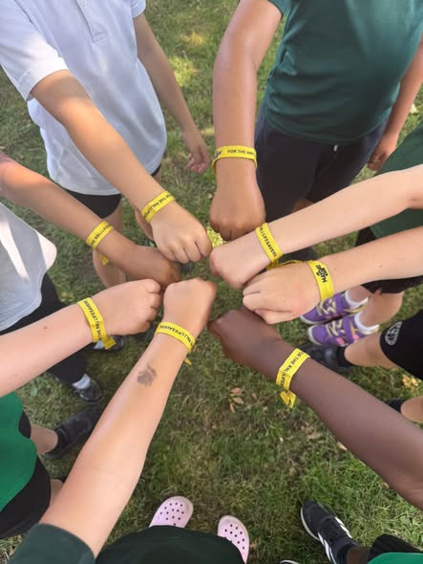
Last week, our Year 3 children had a fantastic visit to the RNLI, where they learned all about staying safe in and around the water.
As a special thank you for their amazing fundraising efforts during our Mile a Day in May, the children were each presented with a Mile a Day wristband after raising an incredible £700!
A huge thank you to the RNLI for such an engaging and informative visit, and to all of our families and supporters who helped make this fundraising achievement possible.

Deal Castle
Year 1 had an exciting trip to Deal castle where they learned about the features of castles. They walked around the grounds and learned about Henry VIII and how he used the castle for defense.
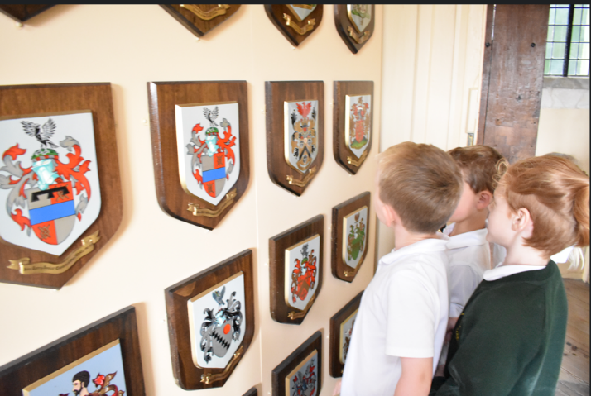
Inside they learned how the fortress worked. The children also explored the Rounds passage which encircles the whole castle. Many Thanks to all of the parent helpers who accompanied the children and supported the trip.
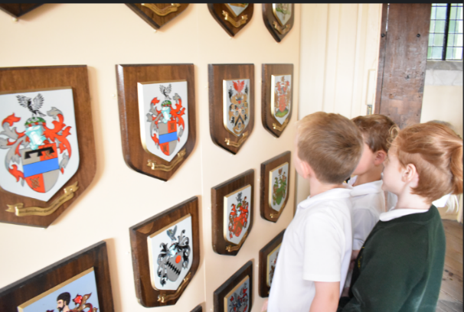
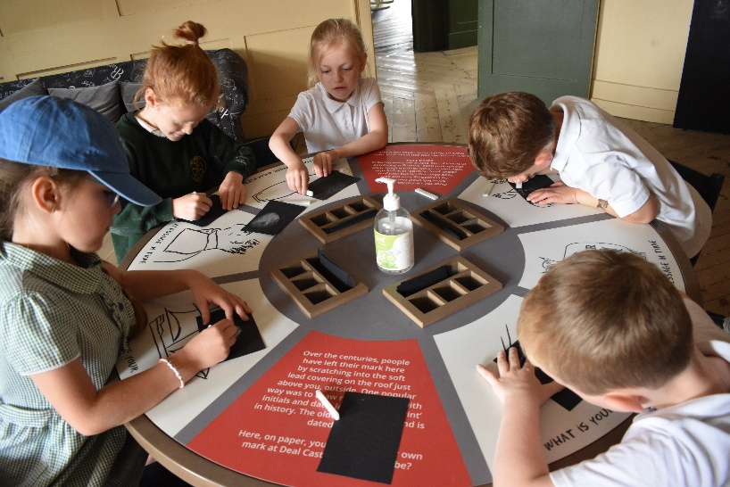

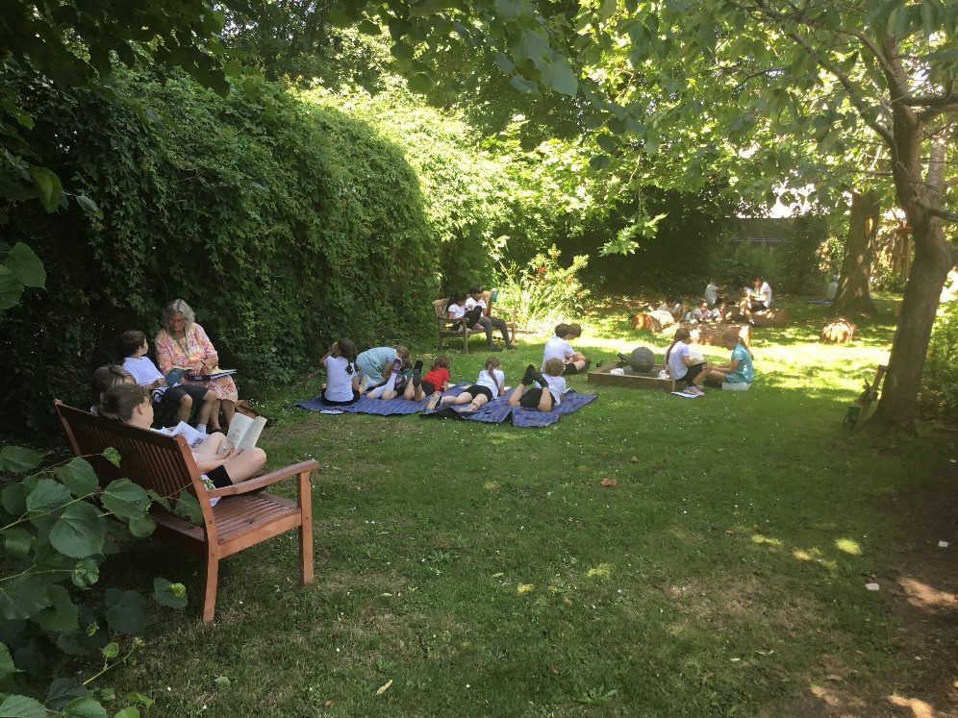
Our Community Garden
The children took refuge in this garden for some of their lessons during the heatwave last week. Reading was a favourite during this time. Many thanks to St. Georges’ Church and all of the donations received which has enabled us to create this reflective space.

Sports Day
Thank you so much for supporting the event and for attending. The children all did amazingly well. Such good sportsmanship was seen, resilience, courage and teamwork. Well done children! Red Team were the winners this year!
Summer Fair this Friday from 2.30pm
This takes places this Friday from 2.30pm. You have the option to pick up your children from 2.30pm on this day to enjoy the Fair. If you would prefer not to do this then we will of course keep the children until the normal time of 3.15pm. The choir will start the Summer Fair off, followed by Year 3 recorders and DAPA Dance. After School Club will be open as normal, these children will be in the library on this day. EYFS collection point will be from the KS1/2 playground on this day and not the usual gate collection point. For emergency access the school car park will be closed on this day.

Thank you so much for all of the contributions for the Summer Fair. The PTFA are raising money to improve our playground markings and have asked the children to choose some designs that will then be put in during the summer holidays.
Urgent Re-call Squeezy dumplings
These toys present a serious chemical risk. Please do not allow the children to bring these into school and we would strongly advise you to take these back to the supplier or dispose of them safely. For more information see https://www.gov.uk/product-safety-alerts-reports-recalls/product-recall-squeezy-dumplings-2606-0196
Scooter Week
School Council would like a Scooter week whereby children can use their scooter in a designated area on the playground at lunchtime. This will be week beginning Monday 6th July. Years 1 and 2 on Monday 6th July, Year 3 on Tuesday 7th July, Year 4 on Wednesday 8th July, Year 5 on Thursday 9th July and Year 6 on Friday 10th July. Children will also need to bring in a helmet to wear on these days when they ride their scooter. If it works well then, the children would like to do more of this in the future.

Diary Dates This term
Thursday 2nd July Transition Day at Secondary school for Year 6. Years R,1,2,3,4,5 move up to their new teachers for the day
Friday 3rd July Summer Fair at 2.30pm
Week Beginning Monday 6th July Scooter Week: Years 1 and 2 on Monday, Year 3 on Tuesday, Year 4 on Wednesday, Year 5 on Thursday and Year 6 on Friday
Thursday 9th July Open Evening 3.30-5.30pm
Wednesday 15th July End of year production to Year 6 parents at school. BBQ for children afterwards – more details to follow.
Tuesday 21st July Leavers’ Service at St George’s Church 1.30pm Year 6 parents Invited only.
Term finishes on Tuesday 21st July and we welcome the children back to school on Wednesday 2nd September.

