KS 2 Music - skill progression
Year 3
Singing
- Sing a widening range of unison songs of varying styles and structures with a pitch
range of do–so or more, tunefully and with expression. Perform forte and piano, loud and soft.
- Perform actions confidently and in time to a range of action songs.
- Clap a steady beat with others, changing the speed of the beat as the
tempo of the music changes.
- Perform in school assemblies.
Listening
Suggested pieces, though not exclusively the following:
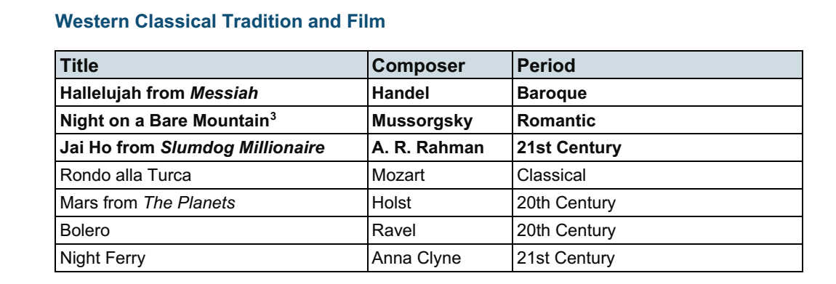
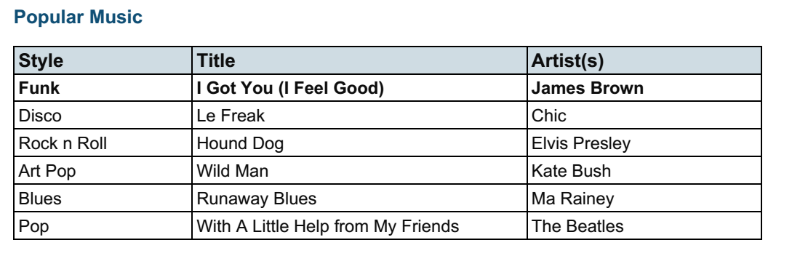
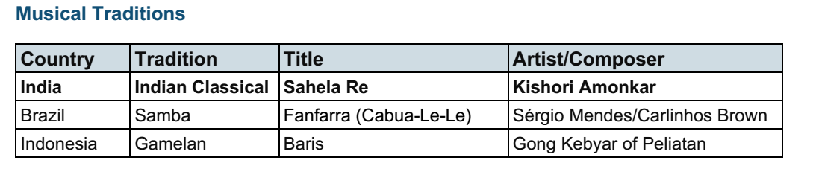
Composing
Improvise:
- Become more skilled in improvising (using voices, tuned and untuned
percussion and instruments played in whole-class/group/individual/instrumental
teaching), inventing short ‘on-the-spot’ responses using a limited note-range.
- Structure musical ideas (e.g. using echo or question and answer phrases) to
create music that has a beginning, middle and end. Pupils should compose in
response to different stimuli, e.g. stories, verse, images (paintings and
photographs) and musical sources.
Compose
- Combine known rhythmic notation with letter names to create rising and falling
phrases using just three notes (do, re and mi).
- Compose song accompaniments on untuned percussion using known rhythms and
note values
Performing
- Develop performing skills using tuned percussion and a melodic instrument
(Recorder/Ukulele).
- Play and perform melodies following staff notation using a small
range as a whole class or in small groups.
Reading Notation
- Introduce the stave, lines and spaces, and clef. Use dot notation to show higher
or lower pitch.
- Introduce and understand the differences between crotchets and paired
quavers.
- Apply word chants to rhythms, understanding how to link each syllable to one
musical note.

Year 4
Singing
- Continue to sing a broad range of unison songs with the range of an octave or more pitching the voice accurately and following directions for getting louder (crescendo) and quieter (decrescendo).
- Sing rounds and partner songs in different time signatures (2, 3 and 4 time and begin to sing repertoire with small and large leaps as well as a simple second part to introduce vocal harmony
- Perform in school assemblies.
Listening
Suggested pieces, though not exclusively the following:
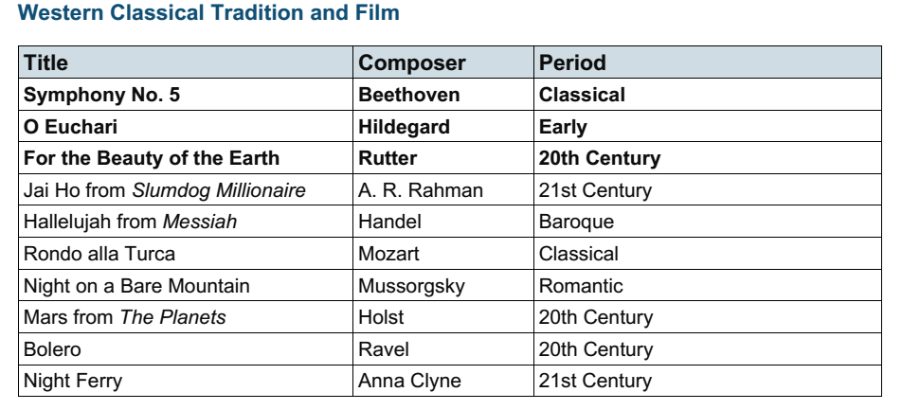
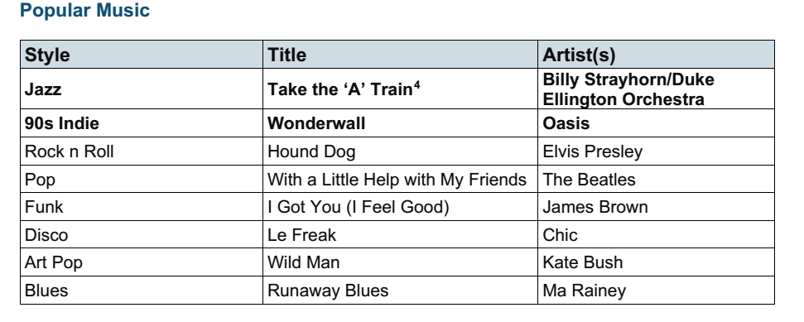

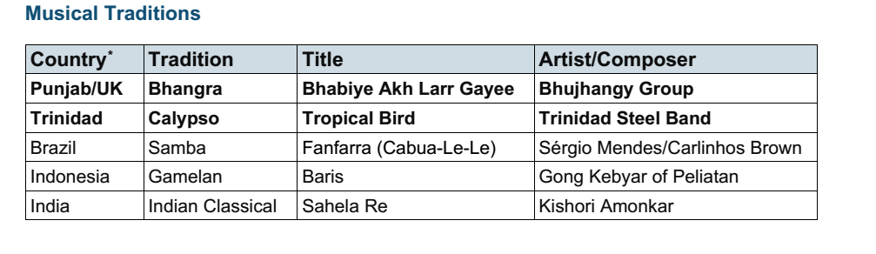
Composing
Improvise
- Improvise on a limited range of pitches using instruments, make use of musical features including smooth (legato) and detached (staccato).
- Begin to make compositional decisions about the overall structure of improvisations.

Compose
- Combine known rhythmic notation with letter names to create short pentatonic
phrases using a limited range of 5 pitches. Sing and play these phrases as self-standing compositions.
- Arrange individual notation cards or notate rhythms of known note values (i.e. minim, crotchet, crotchet rest and paired quavers) to create sequences of 2-, 3- or 4-beat phrases, arranged into bars
- Explore developing knowledge of musical components by composing music to create a specific mood, for example creating music to accompany a short film clip
- Introduce major and minor chords.
- Capture and record creative ideas using any of:
o graphic symbols
o rhythm notation and time signatures
o staff notation
o technology
Performing
Instrumental Performance
- Develop skills further using a range of instruments
- Play and perform melodies following staff notation using a limited range as a whole-class or in small groups.
- Perform in two or more parts (e.g. melody and accompaniment or a duet) from
simple notation using instruments played in whole class teaching. Identify static
and moving parts.

Reading Notation
- Introduce and understand the differences between minims, crotchets, paired
quavers and rests.
- Read and perform pitch notation within a defined range (e.g. C–G/do–so).
- Follow and perform simple rhythmic scores to a steady beat: maintain individual
parts accurately within the rhythmic texture, achieving a sense of ensemble

Year 5
Singing
- Sing a broad range of songs from an extended repertoire with a sense of ensemble
and performance. This should include observing phrasing, accurate pitching and
appropriate style.
- Sing three-part rounds, partner songs, and songs with a verse and a chorus.
- Perform in school assemblies and in school performance opportunities.

Listening
Suggested pieces, though not exclusively the following:

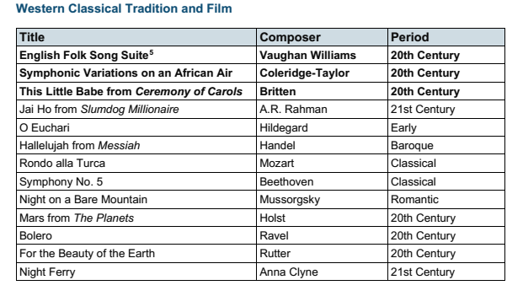
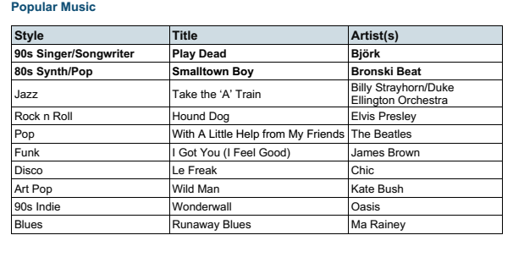

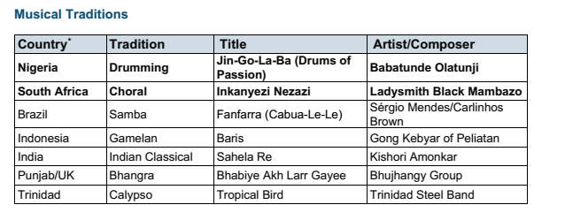

Composing
Improvise
- Improvise freely over a drone, developing sense of shape and character, using
tuned percussion and melodic instruments.
- Improvise over a simple groove, responding to the beat, creating a satisfying
melodic shape; experiment with using a wider range of dynamics, including very
loud (fortissimo), very quiet (pianissimo), moderately loud (mezzo forte), and
moderately quiet (mezzo piano).

Compose
- Compose melodies made from pairs of phrases in either major or minor key
suitable for the instrument being used. These melodies can be enhanced with rhythmic or chordal accompaniment.
- Working in pairs, compose a short ternary piece.
- Use chords to compose music to evoke a specific atmosphere, mood or environment.
- Capture and record creative ideas using any of:
o graphic symbols
o rhythm notation and time signatures
o staff notation
o technology
Performing
Instrumental Performance
- Play melodies on tuned percussion, melodic instruments or keyboards, following
staff notation written on one stave and using notes within the Middle C–C′/do–do
range. This should initially be done as a whole class with greater independence
gained each lesson through smaller group performance.
- Understand how triads are formed, and play them on tuned percussion, melodic
instruments or keyboards. Perform simple, chordal accompaniments to familiar
songs.
- Perform a range of repertoire pieces and arrangements combining acoustic
instruments to form mixed classroom ensembles.
- Develop the skill of playing by ear on tuned instruments, copying longer phrases
and familiar melodies.
Reading Notation
- Further understand the differences between semibreves, minims, crotchets and
crotchet rests, paired quavers and semiquavers.
- Understand the differences between 2/4, 3/4 and 4/4 time signatures.
- Read and perform pitch notation within an octave (e.g. C–C′/do–do).
- Read and play short rhythmic phrases at sight from scores, using
conventional symbols for known rhythms and note durations

Year 6
Singing
- Sing a broad range of songs, including those that involve syncopated rhythm, with a sense of ensemble and performance. This should include observing rhythm, phrasing, accurate pitching and appropriate style.
- Continue to sing three- and four-part rounds or partner songs, and experiment with positioning singers randomly within the group in order to develop greater listening skills, balance between parts and vocal independence.
- Perform in school assemblies, school performance opportunities and to a wider audience.
Listening
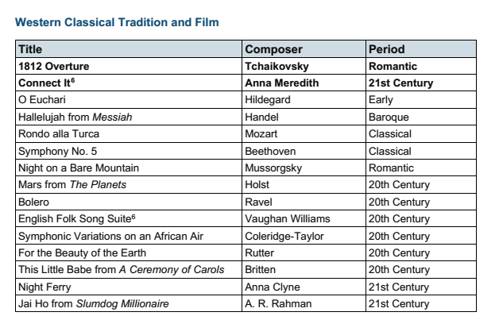
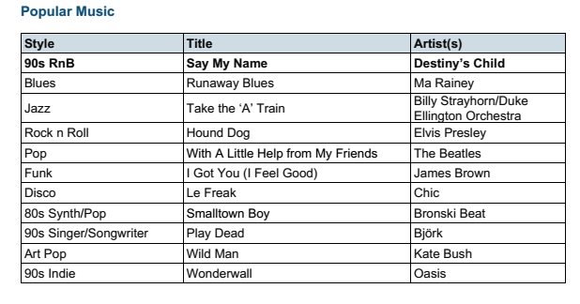
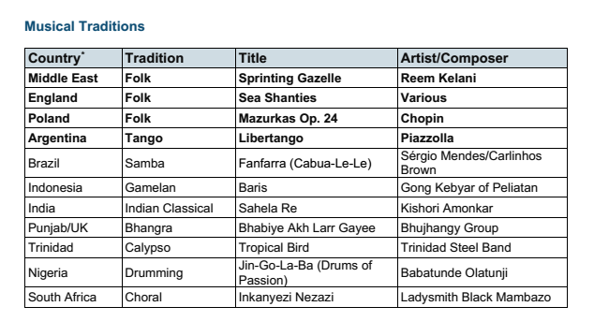

Composing
Improvise
- Extend improvisation skills through working in small groups to:
• Create music with multiple sections that include repetition and contrast.
• Use chord changes as part of an improvised sequence.
• Extend improvised melodies beyond 8 beats over a fixed groove, creating a
satisfying melodic shape

Compose
- Plan and compose an 8- or 16-beat melodic phrase using scales
(e.g. C, D, E, G, A) and incorporate rhythmic variety and interest. Play this melody
on available tuned percussion and/or orchestral instruments. Notate this melody.
- Compose melodies made from pairs of phrases in either major or minor keys.
- Add rhythmic or chordal accompaniment.
- Compose a ternary piece; use available music software/apps to create and record
it, discussing how musical contrasts are achieved.

Performing
Instrumental Performance
- Play a melody following staff notation written on one stave and using notes within
an octave range (do–do); make decisions about dynamic range.
- Αccompany this same melody, and others, using block chords or a bass line. This
could be done using keyboards, tuned percussion or tablets, or demonstrated at
the board using an online keyboard
- Engage with others through ensemble playing with pupils taking on melody or accompaniment roles

Reading Notation
- Further understand the differences between semibreves, minims, crotchets,
quavers and semiquavers, and their equivalent rests.
- Further develop the skills to read and perform pitch notation within an octave (e.g.
C–C/ do–do)
- Read and play confidently from rhythm notation and rhythmic scores in up to
4 parts that contain known rhythms and note durations.
- Read and play from notation a four-bar phrase, confidently identifying note names
and durations.

