What is Spirituality?
It is very difficult to put into words what 'spirituality' actually is because it is a very personal experience. It differs from person to person, and often spirituality changes within people during their lifetime. Spirituality is not the same as having a religion or faith; a person can be spiritual without having a particular faith.
As a school, we have defined spirituality as:
"Spirituality is not something we can see; it is something we feel inside ourselves. It is about awe and wonder, asking questions, inspiration and being aware of something 'bigger' outside of ourselves. "
The language sometimes used to define spirituality is not child-friendly, so when talking to children about it we will refer to:
A sense of awe and wonder
Care for nature and living things
Wanting to love and to be loved by people
Children are born inquisitive, and it is our duty to nurture this natural curiosity and guide them towards looking at the world and noticing, with awe and wonder, the natural and man-made delights all around us. We want to encourage them to ask 'big questions' about life, religion, nature, science and any other area of fascination.
Caring for Nature and Living Things
We provide many opportunities for children to learn about nature and the role they play in protecting our world. As a Church School, this is especially important. We have a very active Eco Committee and Gardening Club. We have provided bird feeders and owl boxes. Through science and topic work, children learn about the world and how they can care for living things. Our School has been awarded the Eco Schools Award.
Love
We are a very caring school and pride ourselves on our ethos of family. Through our Christian Values, we teach children to care for friends, family and the community.

Spirituality is woven through the fabric of school.
- Learners are given the space to wonder and ask questions; to imagine a better world and to think of ways of making it better.
- Learners develop life skills to live with mystery – knowing there are not always answers to questions and that this is okay.
- Learners are encouraged to develop a sense of awe and wonder about the natural world which extends to action to protect and nurture that world.
- Learners are given the meaningful opportunities to consider the existence of God or a Divine other beyond what can be seen?
- Learners encouraged to never stop asking questions?
Our School Responsibilities
Schools are required to develop children’s spirituality as part of the curriculum requirements in all parts of the UK and therefore as it is written into what we are required to do. Taking on board spiritual development can make a positive contribution to our individual wellbeing and the wellbeing of the whole school community.

Health and Well-Being
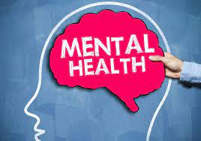
Nowadays, the promotion of health and wellbeing should be embedded into school life and learning for all children and young people. Although for many years the emphasis was on the physical aspects of healthy living with high profile campaigns around healthy eating and exercise, we now have a growing awareness of the equally important role played by mental wellbeing in the lives of children of all ages. Spirituality forms a part of that.

It is now recognised by many professionals that spirituality can make a significant positive contribution not only our mental health but also to our physical health and wellbeing.
Good mental health enables us to learn, feel, express and manage a range of positive and negative emotions; to form and maintain good relationships with others (and ourselves) to cope with and manage change and uncertainty and to develop resilience.

Spiritual health and wellbeing will guarantee positive mental health but it can make a difference. We must be prepared not just to embrace it but to actively promote spirituality’s inclusion in any and all mental health promotion practices and procedures.

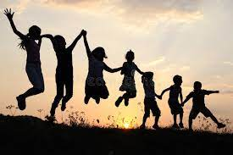
We cannot create spiritual children, because they are already spiritual beings when they come to school, but it is our commitment to them to nurture their spirituality.

‘There are two ways to live your life. One is as though nothing is a miracle. The other is as though everything is a miracle’

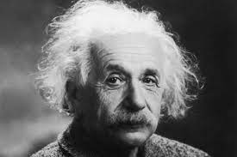
Albert Einstein

Deal Parochial School

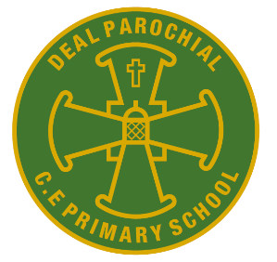
Vision statement
Our School is built on the teachings of the Bible and inspired by The Gospel Values of Faith, Hope and Love.
Our Christian ethos is upheld by respecting humanity fostered through our community
that is welcoming, inclusive and forgiving.
Together we flourish through courageous learning, friendships and generosity.
TO BE THE BEST THAT I CAN BE – THE WAY GOD INTENDS

Information for parents and carers

Spirituality at Parochial

As Jesus said in John 10:10

‘I have come that they may have life and have it to the full.’

