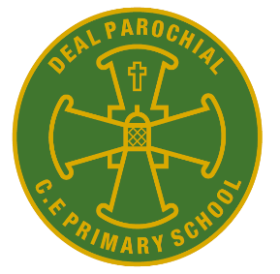
Year 2
Amelia Earhart
Term 6

Dear Parents / Carers and Children,

Welcome back to school! We hope you all had a lovely half term break.

We have got another busy term ahead of us. Thank you again for your continued support so far. The class has been working very hard last term. They have embraced the changes I have made and have had a good go at challenges set for them. We are very proud of their growing maturity and positive behaviour for learning.
If you have any issues, concerns or questions, please find me at the end of the day for a quick informal catch up.
I would like to tell you about the wonderful learning we will be doing this term in Earhart Class.

Our exciting learning in Term 6
Literacy: This term we will continue to study the Twits, which we started last term. One of our aims is to write a recount of one of the tricks Mr or Mrs Twit played on their spouse. We will also be writing a disgusting recipe for the Twits. After finishing these, we will be moving on to poetry and creating our own poems using alliteration.
Maths: We will be continuing to learn how to read scales and will learn how to tell the time. It would be great if you could reinforce this learning at home eg. when you are measuring ingredients for cooking/baking and talking about time/ reading an analogue clock.
Geography: This term we will be continuing to investigating the question ‘Why does it matter where my food comes from?’ To answer this question we will be investigating dairy farming and comparing the local farming with Costa Rica, explaining that different weather conditions have an effect on what crops are farmed.
RE: We are continuing with our Big question from last term is ‘Who is a Muslim and what do they believe?’ We are focusing on Islam, and learning to understand some of their beliefs.
Science: This term we are continuing to learn about plants and what they need to survive. We will be creating a fair test and observing seeds growing in different environments, along with observing the lifecycle of a plant.
PSHE: Changing me. During this unit we will be recognise cycles of life in nature, talking about the differences between young and old, and the differences between boys and girls. A letter with further information will follow soon.
Computing: Programming quizzes. Learners begin to understand that sequences of commands have an outcome, and make predictions based on their learning. They use and modify designs to create their own quiz questions in ScratchJr, and realise these designs in ScratchJr using blocks of code. Finally, learners evaluate their work and make improvements to their programming projects.
Art: Last term, we learnt all about architecture and had brilliant discussions about different building, such as the impressive designs of Frederick Hundertwasser. This term we will become architects and will create our own unique design.
Spellings: The overview for the term is in the front of homework folders, and attached to the newsletter. The Year 2 spelling patterns will be taught on a Friday morning and will be covered in short sessions during the week. I will also send home a sheet to show which sounds and words we have been learning in class daily. You could support your child by practising spellings at home.
PE: On a Wednesday we have Tennis at Tides so please make sure your child is wearing the correct PE kit, their house colour as a top and suitable shots or tracksuit bottoms. We will also have PE on a Friday with Mrs Reynolds, where we will be participating in some Athletics and practising for Sports Day. Please ensure your child is appropriately dressed.

Reading in Year 2
After assessing the class, we felt some children needed to consolidate certain sounds. For this reason, your child/ children may have brought home books, which they have already read. This term we will be focusing on different comprehensions skills in class. The children will continue to have the opportunity to choose books from our class library to read at home. They will also receive a book every week, which should meet their ability. Please read with your child for at least 10 minutes every night and record this in their reading records. When you read with your child/children, please spend some time talking about the story they are reading, ask questions such as ‘what happens when…’ or ask them to predict what might happen next, and who the characters are. This will help with your child’s comprehension and reading progress.
It is very important that their book and reading record are handed in every day.

General reminders
- Tennis is on a Wednesday. Please send your child to school in their PE kit! We will be walking to Tides, so please ensure to send them to school with their coats for those colder days. Mrs Reynolds will be teaching athletics on a Friday afternoon.
Long hair should be tied back, and earrings removed. Please ensure items, such as jumpers and hats, are clearly labelled.
- Please make sure your child brings a water bottle into school, which is clearly labelled with their name. It is important that the children stay hydrated, especially now the weather is starting to become warmer. NO JUICE OR SQUASH PLEASE.
- As the weather is getting hotter, please ensure your child is wearing sun cream and brings a sun hat to school.
- Homework will be going out on a Friday and will be due back the following Wednesday. 😊 Home work will consist of Phonics/ literacy and Maths.
If you have any queries, questions or concerns about your child, please do not hesitate to contact me either in person
at the end of the day, by writing a note in the reading record or via email:
schlamkowd@deal-parochial.kent.sch.uk

Thank you for your support.
Miss Schlamkow and the Year 2 team

Geography vocabulary
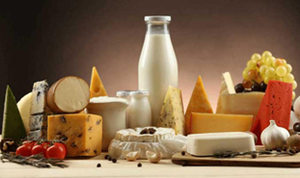
diary product: a product containing or made from milk | Settlement: Settlements are the places where people settled to build permanent homes. | Industry:  An industry is a group of companies which produce similar goods and/ or services.
 |  | 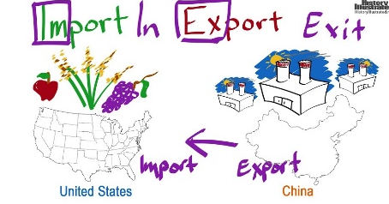
Trade: Trade is an exchange of goods or services | Plantation: an estate on which crops such as coffee, sugar, and tobacco are grown | Import: bring (goods or services) into a country from abroad for sale
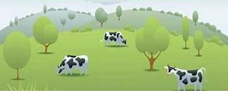 | 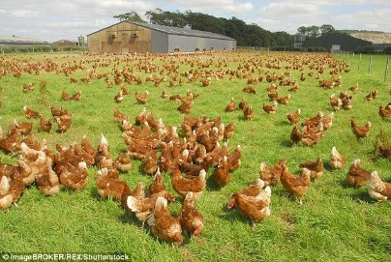 | 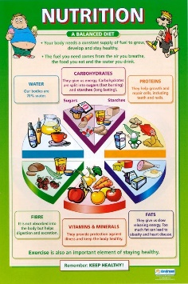
Pasture: land covered with grass and other low plants for grazing animals, especially cattle or sheep | Free- range: animals kept in natural conditions so they can roam around freely | Nutrition: Nutrition is the study of food and how it works in your body. Nutrition includes all the stuff that's in your food, such as vitamins, protein, fat, and more.

‘Who is a Muslim and what do they believe?’RE vocabulary
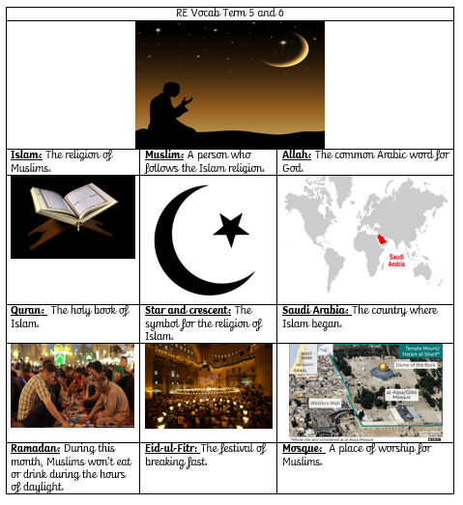

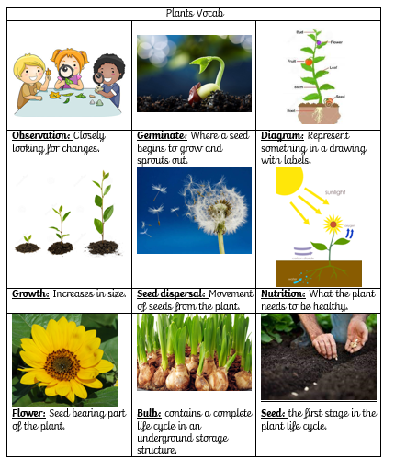

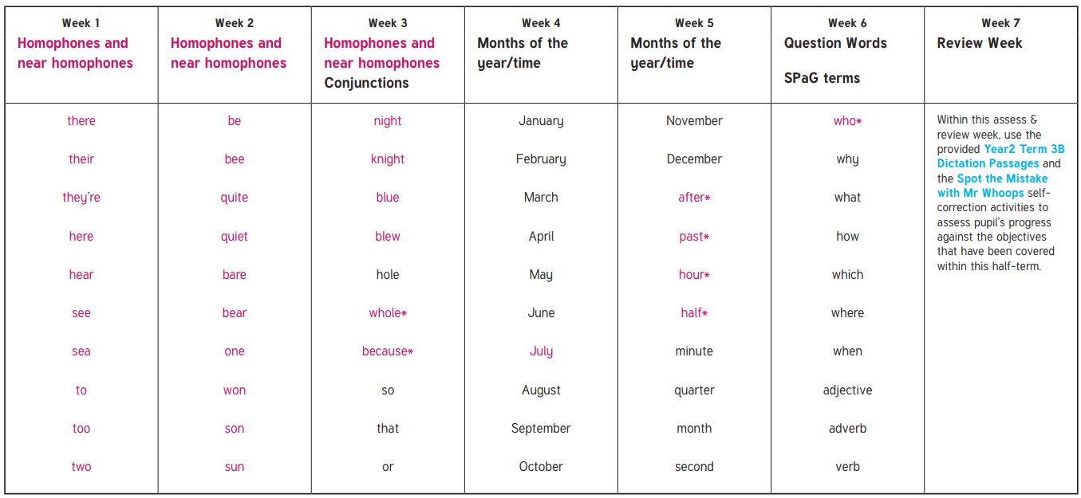
My spellings this term are:

