Autumn term 2
Dear Families
It was fabulous to meet and greet so many families into school this week as we held the teacher consultation evenings. Thank you for coming and thank you for all the support and kind comments that the teachers received in the meetings. If you missed the opportunity to meet your child’s teacher, don’t worry, you can phone the school to make an alternative appointment. Children do really love knowing that you have looked through their books and heard some lovely things said about them. We are always happy to meet with our families.
Next week is Road safety awareness week. This school has signed up to Road Safety Week so that we can encourage everyone to stop and give Road safety some thought
At school we aim to raise awareness and importance of road safety for everyone.
The goal of this year's Road Safety Week was to start a national conversation about speed, and why people still think it’s ok to drive above the limit or too fast for the road conditions. That conversation feels well underway with heavy media coverage, political debates and social media discussions taking place all across the UK! We’re so glad you have signed up to Road Safety Week to take part in this campaign and we’re delighted to share tools and resources to help you be part of this conversation.
With five people killed on UK roads every day – whoever you are and however you travel, we need to talk about SPEED.
The formula is simple:
the higher the speed, the longer the stopping distance, the harder the crash, and the greater the risk of death and injury.
Within our school grounds we do have a few potential road hazards that through awareness and careful curtesy we can avoid any accidents.
The traffic can quickly become congested around the school gates and drop off circle. Please try to avoid parking and use the drop off circle as a means of allowing children to jump out of the car and move to their entrance gate.
I am aware that some children need to be walked to the entrance and this is fine.
Please park safely, not in front or on our zebra crossing.
Equally, in order to keep the flow of traffic in and out of the school it would be greatly appreciated for drivers to avoid parking near the zig – zag lines in the road at the school entrance This creates blind spots for pedestrians and restricts vision which could result in an accident. Please try to keep the flow of traffic moving and to respect the safety of everyone.
Be BRIGHT AND BE SEEN – HIGH VIZ DAY Friday 17th November. Everyone is invited to go as crazy as you dare! You can simply wear a reflective arm band or you can dress in the brightest, most dazzling, and reflective clothes you can. As the dark winter returns, this is a fun way to remind us all that being seen by drivers can save lives.
During the week we will carry out some road safety awareness sessions with the children and have created some activities for them to bring home.
Other school events coming up.
Scholastic Book fair starts Thursday 16th November in the school Hall. Last day of orders is Tuesday 21st
Please come along to the school Scholastic Book Fair. We time it just right for families to have the opportunity to select some superb, highly recommended children’s books as presents for the big C that is fast approaching ! You will find posters and fliers with information about the fair, the hot chocolate and bacon sandwiches, cake sale and much more that our library Ambassadors have been planning to entice you all in and spend some money. Don’t forget that in buying books you also help to build up a percentage discount for the school to also purchase some new books for our library. Everyone is a winner!! The EYFS class are selling cakes at the book fair. They are raising money to replace the greenhouse – which was brand new - that was sadly blown down in the storm last week.
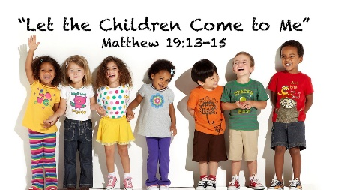
This week we have been thinking about creating a better world through Education. Being inspired by the Bible Matthew 19:13-15. Where Jesus speaks out and show that children are important.

A moment for reflection
Father God, lay a blanket of protection over children who cannot attend school, especially those whose educations are disrupted by conflict, emergencies, and natural disasters.
In Your mercy, we pray for You to provide opportunities for learning so that through education, children find the hope and skills for a better future.
Amen

Have a safe and dry weekend.
With kind regards
Ms Justine Brown

