# Why is prayer important?

# C:\Users\porteousk\AppData\Local\Microsoft\Windows\INetCache\Content.MSO\861205B6.tmp

# Children and young people are innately curious about life. Growing up raises lots of questions, some to do with their experience, both the good and the bad, and some to do with their sense of wonder at the universe we live in and whether there’s more to life than meets the eye. Many have an interest in the non-material aspects of life, the spirit or soul, and want to explore how these ideas and experiences help them to develop their own sense of identity, self-worth, personal insight, meaning and purpose.

# At Deal Parochial, we want to equip the children with the life tools that will enable them to be reflective, kind and connected to the world around them.

# What is Prayer?

Whether people have a faith or no faith, here at Deal Parochial we believe in the power of prayer. It is the ability to be able to connect spiritually that enables us to flourish and grow.

Christians describe prayer as a conversation with God. Christians believe that God created everyone to be in relationship with him, and that he loves to hear from each one as often as possible. God has made himself know to many who have reached out to him with an open heart.

Prayer can be silent, sung or said out loud. It can use set words or a person’s own words.

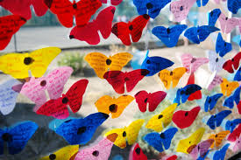In prayer, Christians lift their minds and hearts to God. There are many different types of prayer, including:

*Adoration* – praising God for his greatness and admitting dependence on him.

*Confession* – owning up to sin and asking for God’s forgiveness.

*Thanksgiving* – thanking God for his many blessings

*Petition* – asking God for something e.g. healing, courage, wisdom

*Intercession* – asking God to help others who need it, e.g. the sick, poor those suffering war.

**Prayer at Parochial**

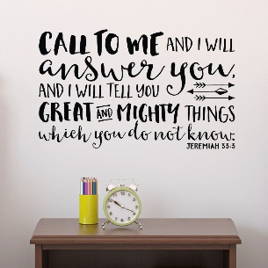We are a Church of England school with a distinctive Christian Ethos that is the heartbeat of school. All those who wish to do so will have regular opportunities to pray, be still and reflect. We

have daily collective worship which includes opportunities to pray and always accompanied by the option to reflect.

There are also prayer stations in classes, in communal areas and in our Reflective Garden.

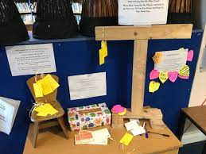Pupils talk about the value of prayer and reflection both in formal and informal contexts and how being still and reflective in their own lives can be helpful.

The school also has regular prayer days where the children can experience different methods of active prayer focusing on various world needs or themes.

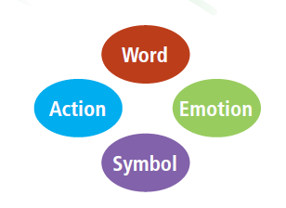We know that there are different spiritual styles and we ensure that all these styles are included in the prayer activities that we practice.

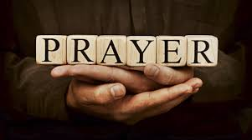

How do we include different faiths?

All faiths are equally welcome here at Deal Parochial School. We welcome and celebrate diversity. This includes respecting and learning about different prayer rituals.

Benefits of prayer

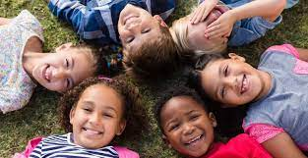The practice of prayer during childhood

Is linked to better physical, mental and emotional well-being.

Prayer helps create positive habits, as well as a designate a specific time, space and mindset to disconnect from everything and connect either with god or spiritually. These are transferable practices that can be used across other areas of life.

With that in mind, here’s how prayer can help develop the following positive life disciplines:

Focus / time management / Trust in God and others / A better understanding of the Bible and God’s story /

Prayer is a conversation with God, but is also a great spiritual practice that can help attain positive habits and disciplines. It’s good for the heart and soul and can help achieve your dreams and goals as well as create people who are empathetic to the world around them.

**Deal Parochial School**

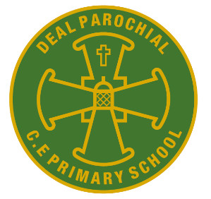

**Vision statement**

**Our School is built on the teachings of the Bible and inspired by The Gospel Values of Faith, Hope and Love.**

**Our Christian ethos is upheld by respecting humanity fostered through our community**

**that is welcoming, inclusive and forgiving.**

**Together we flourish through courageous learning, friendships and generosity.**

**TO BE THE BEST THAT I CAN BE – THE WAY GOD INTENDS**

**Information for parents and carers**

# Prayer at our school

# Prayer at Parochial is

# Invitational, Inclusive & Inspiring.

# It is a natural and valued part of the culture of the school, however it is not compulsory or forced.

